

Gold Problem #7: Skyscrapers
Background Information: The skyscrapers problem is a logic problem based upon a 5x5 grid of integers. Each row and column in the completed puzzle will contain one instance of each of the numbers 1, 2, 3, 4, and 5. Below are the puzzle starting configuration, and its completed solution.

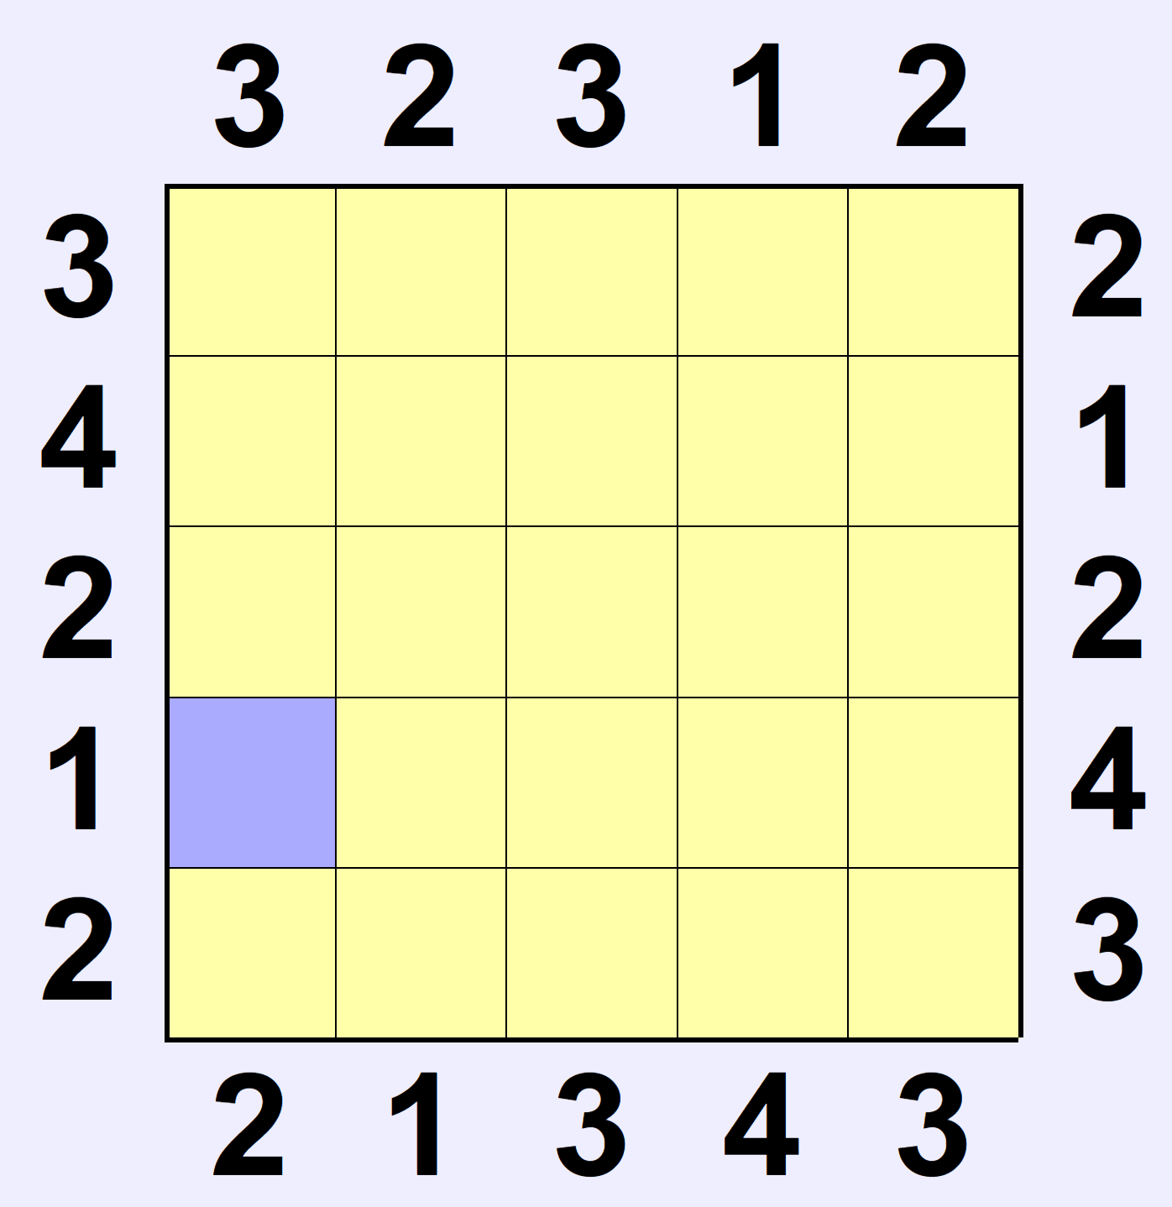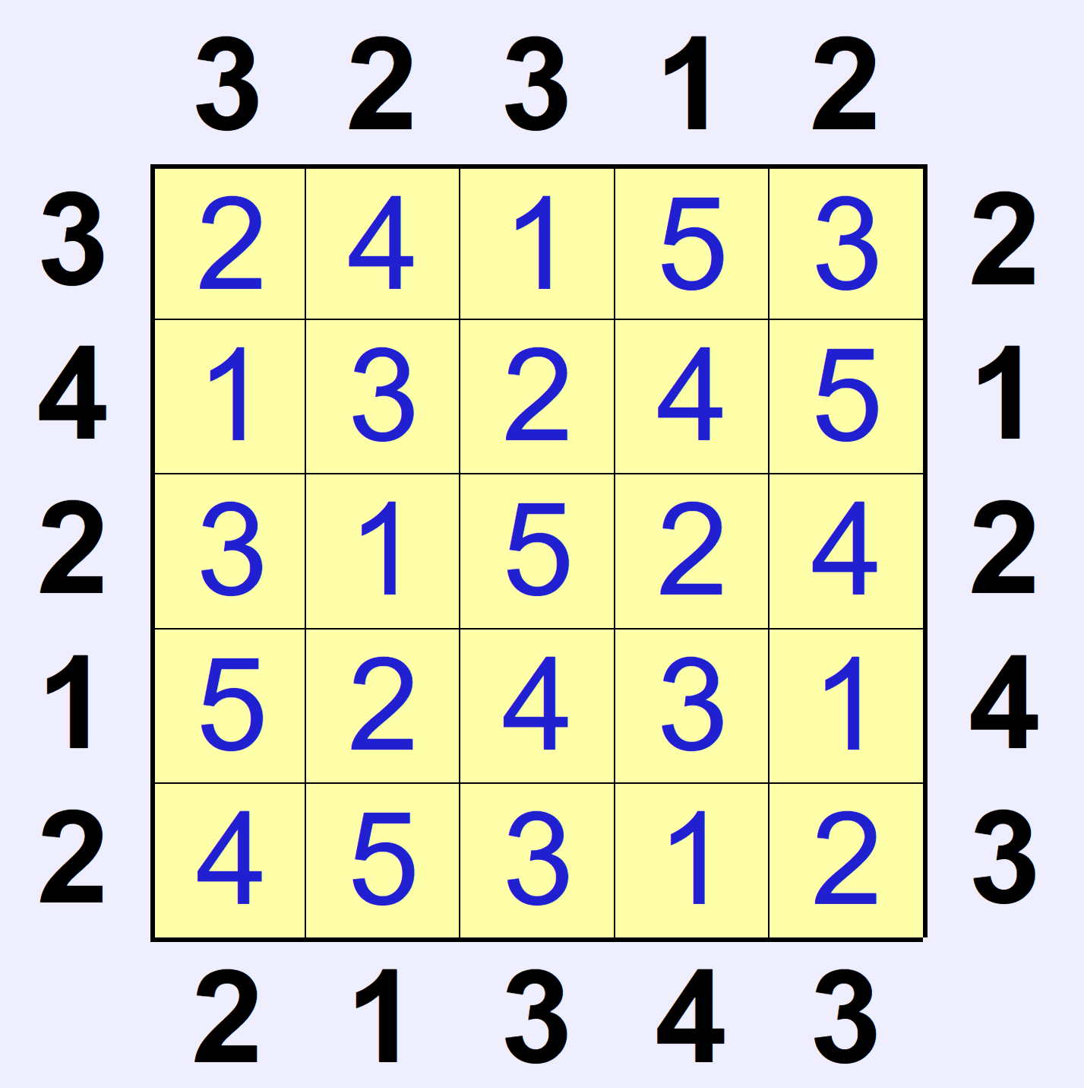

Each integer of the grid that you place represents the height of a skyscraper. The bolded numbers along the sides represent the number of skyscraper peaks that you can see when you look into the grid from the number. For example, for the top row, there is a 3 on the left, and a 2 on the right. The 3 means that you can see three skyscraper peaks (in this case the 2, 4, and 5) gazing into the grid row from the left. But the 2 means that you can see two skyscraper peaks (in this case, the 3 and the 5) gazing into the grid row from the right. You cannot see a smaller skyscraper behind a taller one, obviously because it would be blocked from sight.

So, given the 25 bolded numbers indicating the number of skyscrapers seen from each row/column orientation, your program must find the heights of all skyscrapers in the grid.

Programming Problem:
Input: Four rows of 5 numbers, each on their own line, representing the top, bottom, left, and right bolded numbers.
Output: 5 lines of 5 numbers representing the grid solution

Example 1: Input:

3 2 3 1 2
2 1 3 4 3
3 4 2 1 2
2 1 2 4 3

Output:
2 4 1 5 3
1 3 2 4 5
3 1 5 2 4
5 2 4 3 1
4 5 3 1 2

