

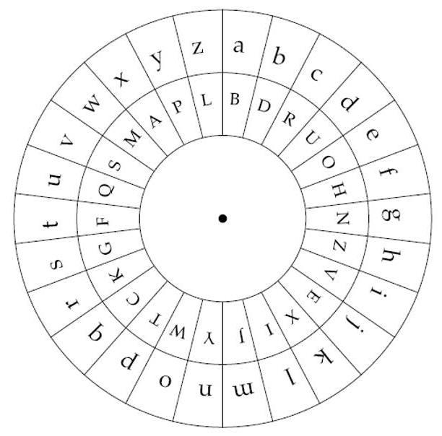
Green Problem #6: Wheel Encryption
Background Information: Enciphering and deciphering wheels were developed as early as the 15th century. On the right is an example of a wheel cipher. The letters a-z form the outer wheel and each letter can be mapped to a letter on the inner wheel. In general, both wheels can be rotated in either a clockwise or counterclockwise direction. Additionally, the encryption scheme can change from the initial encoding. However, for this problem only the inner wheel will be rotated.

Using the wheels in the diagram the word “cat” can be encoded as RBF. However, if you rotated the inner wheel clockwise one letter after encoding the letters “ca” in cat, the final encoding would be RBG, since the inner G was originally under the outer s, but now is under the t. Clockwise rotations are specified by positive numbers. Counterclockwise rotations are specified by negative numbers.

Programming Problem:
Input: On the first input line is a string of the 26 uppercase letters “A” to “Z” for the inner wheel. Each letter appears exactly one time in the string. The 26 uppercase letters for the inner wheel are initially aligned with the letters “a” through “z” of the outer wheel where the first letter for the inner wheel is aligned with lowercase “a”. The second input line has an input message that is a string consisting of letters and possibly non-zero integers that is to be encoded. The string will consist of at least one letter. A positive integer (≤ 100) in the input string indicates that the inner wheel should be rotated clockwise and a negative integer (≥ -100) indicates the inner wheel should be rotated counterclockwise.
Note: embedded integers may occur at any position in the string after the first letter.

Output: The encoding of the input message given the initial inner wheel string.

Example 1: Example 3:

Input: Input:

BDRUOHNZVEXIJYWTCKGFQSMAPL QWERTYUIOPASDFGHJKLZXCVBNM
ca2t edkyln52hymcd

Output: Output:
RBK TRANSFINDER

Example 2: Example 4:

Input: Input:

BDRUOHNZVEXIJYWTCKGFQSMAPL QWERTYUIOPASDFGHJKLZXCVBNM

d27o-2g transfinder

Output: Output:

UYZ ZKQFLYOFRTK

