

Green Problem #4: Integer Triangles

Background Information: Alcuin of York was a scholar, clergyman, poet, and teacher. He was born around 835 CE. He enjoyed posing problems involving counting. One of his most famous counting problems is finding the number of possible integer triangles with a perimeter of positive integer P.

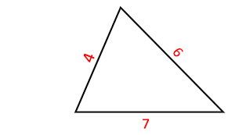
An integer triangle is a triangle that has positive integer values for the length of all three sides a, b, and c. If the length of each side is a positive integer then the perimeter must be a positive integer. By the triangle inequality theorem, the sum of the lengths of any two sides of a triangle must be greater than the length of the third side. For example, if the perimeter of a triangle is 6 then there is only one integer triangle, a = 2, b = 2, and c = 2. Note that most geometers do not count a = 1, b = 2, and c = 3 as a triangle by the inequality theorem. However, some geometers do count it and call this type of triangle a degenerate triangle.

In this problem, you will read in a positive integer P, and output the number of unique integer triangles with integer sides that have a perimeter P. For example, for P = 12 the integer triangle with a = 3, b = 4, and c = 5 is the same triangle as a = 4, b = 3, and c = 5 and it’s also the same triangle as a = 5, b = 3, and c = 4.

Programming Problem:
Input: Positive integer P ≤ 2500.
Output: The number of unique integer triangles (not counting degenerate ones) with perimeter P.

Example 1: Input Example 4: Input:
3 47

Output: Output:
1 52

Example 2: Input: Example 5: Input:

5 2025

Output: Output:
1 85683

Example 3: Input: Example 6: Input:

6 2

Output: Output:
1 0

