

Green Problem #1: Checker Jumping

Background Information: In this classic problem there are m white checkers placed at the left end of a board with one checker for each space and n black checkers on the other end of the board with one checker per space. The board has m+n+1 spaces. The one extra space is in between the 2 groups of checkers. As shown below, m = 3 for the three white checkers, n = 3 for the three black checkers and the length of the board is m+n+1.

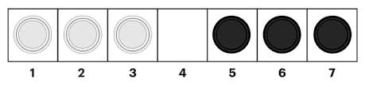

In this problem, you want to move your checkers so that white checkers at spaces 1, 2, and 3 end up on spaces 5, 6, and 7 and the black checkers on 5, 6, and 7 end up on spaces 1, 2, 3. In other words, the two sets of checkers swap sides. A checker can either skootch to an adjacent open space or a checker can jump one adjacent checker of the opposite color into an open space. Checkers may only skootch or jump forward. The number of moves is the sum of the number of skootches and the number of jumps. The classic problem is determining the minimum number of moves required to completely swap the checkers. For the conditions listed above the minimum number of moves is mn + m + n.

Your program will read in values of m and n, and produce the minimum number of moves for a board that has m + n + 1 spaces.

Programming Problem:
Input: Positive integers m and n.
Output: The minimum number of moves necessary to rearrange m white checkers
and n black checkers on a board of length m + n + 1.

Example 1: Input: Example 2: Input: Example 3: Input:

3 2 6

3 4 7

Output: Output: Output:
15 14 55

