
36th Annual High School Programming Contest
Sponsored by | 

April 12, 2024

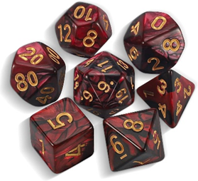
Green Problem #5: Dice Rolls

Background Information: In many role playing games, you have dice with different numbers of sides. For this program, you have 6 types of dice: a 4-sided die, a 6-sided die, an 8-sided die, a 10-sided die, a 12-sided die, and a 20-sided die. Each N-sided die is labeled with an integer from 1 to N. Each die is fairly weighed, so any side can be rolled with equal probability.

Given R separate dice are rolled, where 1 <= R <= 6, how many ways can the number K (the sum of the rolled dice) be reached when rolling all R dice?

Programming Problem:
Input: Integer R, followed by R sizes of dice on {4, 6, 8, 10, 12, 20}, followed by a target sum K.
Output: The number of ways K can be rolled with the given dice.

Example 1: Input: 1
6
3

Output: 1

Example 2: Input: 2

4

8

10

Output: 3

Example 3: Input: 3
20
10
20
2
Output: 0

