### 

**36th Annual High School Programming Contest**

| **Sponsored by** |  |
| --- | --- |

##### April 12, 2024

###### Gold Problem #6:  Snail Mail

Background Information:

In the post offices in the country of Mathenia, there are only 6, 9, and 20 cent stamps. There is an unlimited supply of each type of stamp.

To have a letter sent from the eastern end of the country to the western end requires postage of 15 cents. Can you put exactly 15 cents of postage on an envelope? Yes, you can. Use a 6 cent and 9 cent stamp.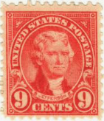

Can you put exactly 16 cents of postage on an envelope? The answer is no!

How about 21 cents? Yes, use two 6 cent stamps and a 9 cent stamp?

What is the largest amount of postage that cannot be put on an envelope with the 6, 9, and 20 cent stamps?

The answer is 43 cents!

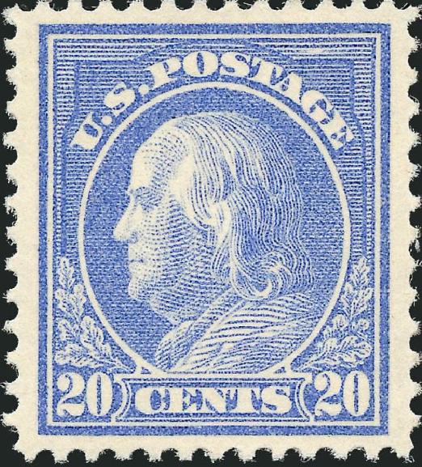

If Mathenia had only 6, 12, and 20 cent stamps, there would be an infinite number of postage amounts that could not be done. This is the case because there’s no way to get an odd value with three even stamps.

If only Mathenia had a 1 cent stamp then every amount of postage could be made!

###### Programming Problem:

Input:   On the first line, a positive integer N between 1 and 5 that indicates the number of different stamps.

On the next N lines, the values of the N stamps in ascending order. The stamps will have unique

integer values between 1 and 50.

Output: Either the largest amount that cannot be made with the unlimited supply of the N different stamps,

or the message INFINITE if there is an infinite number of postage amounts that cannot be made,

or the message ALL if every postage amount can be made.

###### Example 1: Example 2: Example 3: Example 4:

###### Input: Input: Input: Input:

###### 2 3 5 4

###### 3 6 1 2

###### 4 9 3 6

20 5 14

9 20

10

###### Output: Output: Output: Output:

5 43 ALL INFINITE