Siena College’s 32nd Annual High School Programming Contest

Sponsored by Transfinder

March 29, 2019

Green Problem #7: The TRANSFINDER Problem
Background Information: There are mathematical puzzles that are sometimes called cryptarithmetics, alphametics, or word additions. This type of puzzle consists of a mathematical equation among unknown numbers, whose digits are represented by letters. To solve the puzzle, the value of each letter must be identified. One rule for these puzzles is that no digit is used by more than one letter. A second rule is that the final numbers will not have leading zeros. One of the most well-known puzzles was constructed by the famous math problem poser, Henry Dudeney, in 1924. It is: SEND + MORE = MONEY.
It may be helpful to lay out the problem as follows:
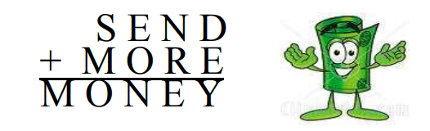
With some good logic, you can reach the only possible solution of
S = 9, E = 5, N = 6, D = 7, M = 1, O = 0, R= 8, and Y = 2 which can be written as follows:
9 5 6 7
+ 1 0 8 5
1 0 6 5 2
We want a program that can check to see if a proposed solution for an addition problem with two addends is correct. For a solution to be correct the arithmetic must be true, no digit can be used by more than one letter, and the final numbers will not have leading zeros.

Programming Problem:
Input: Three words in uppercase on one line, each separated by a space, followed by a line
with three unsigned integers which may or may not be a good solution, each
separated by a space.

Output: The three words on the first line, each separated by a space, followed by a second line with the three integers separated by a space, followed by a third line with the word GOOD if the solution is valid or BAD if not. .

Example 1: Input SEND MORE MONEY Example 2: Input: A B C
9567 1085 10652 1 2 3

Output: SEND MORE MONEY Output: A B C
9567 1085 10652 1 2 3
GOOD GOOD

Example 3: Input TRANS FINDR FIESTA Example 4: Input: AB CB BDB
96842 10456 107298 12 92 202

Output: TRANS FINDR FIESTA Output: AB CB BDB
96842 10456 107298 12 92 202
GOOD BAD
V1

