Siena College’s 32nd Annual High School Programming Contest

Sponsored by Transfinder

March 29, 2019

Green Problem #6: GRID LOCK or GRID UNLOCKED

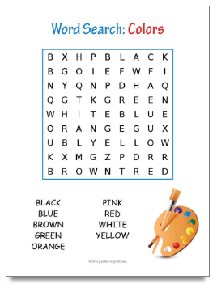
Background Information:
A crucial skill taught in American elementary schools is the ability to do a word search. Students learn to find words in a two dimensional grid of letters. Words may hidden in the grid in the horizontal, diagonal, or vertical direction. The words must be in a straight line.

Programming Problem:
Input: On the first input line, positive integers R and C, 1 ≤ R, C ≤ 16 indicating the
number of rows and columns in the search grid. This will be followed by R strings
of length C. The strings are uppercase letters that form the R by C grid. These lines
of input are followed by a positive integer N ≤ 20 for the number of words that will be searched for in the grid. Finally, there will be N lines of input, each with a word to search for.

Output: N lines of output, one for each word the program tries to find in the grid.
Each output line consists of the searched for word followed by either FOUND or NOT FOUND.

Example 1: Input 3 6

ESUOMG

XDAQOJ

BWSDNL

4

CAT

MOUSE
DOG
TRANSFINDER

Output: CAT NOT FOUND
MOUSE FOUND
DOG FOUND
TRANSFINDER NOT FOUND

V1

