Siena College’s 32nd Annual High School Programming Contest

Sponsored by Transfinder

March 29, 2019

Green Problem #2: Kitchen Conversions
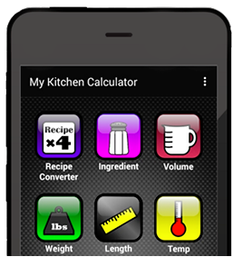
Background Information: Professional and amateur cooks as well as food connoisseurs frequently need to convert between various kitchen units. You have a plan to develop a full-fledged cooking app. However, you are participating in a programming contest and cannot get started until later tonight. But as luck would have it, this problem will help get you started. You will write a program that will do some basic conversions. The following relationships may be helpful.
- 3 teaspoons in 1 tablespoon
- 16 tablespoons in 1 cup
- 2 cups in 1 pint
- 2 pints in 1 quart
- 4 quarts in 1 gallon
For this problem, all conversions will result in
integer values. For example: your program will
convert 19 teaspoons to 6 tablespoons (not 6.33).

Your program will input a positive integer N followed by two by strings S and T from the set:
{TEASPOONS, TABLESPOONS, CUPS, PINTS, QUARTS, GALLONS}
and output K which is the conversion of N units of S into K units of T. For tonight, conversions should use integer division (see problem 1). Also, unit S will be not be the same as unit T.

Programming Problem:
Input: N, S, and T on one line, each separated by one space (as described above)
N will be ≤ 50,000.
Output: K (an integer as described above)

Example 1: Input: 3 GALLONS QUARTS

Output: 12

Example 2: Input: 35 QUARTS GALLONS

Output: 8

Example 3: Input: 101 CUPS QUARTS

Output: 25
V1

