Siena College’s 32nd Annual High School Programming Contest

Sponsored by Transfinder

March 29, 2019

Green Problem #1: Starting with some Arithmetic
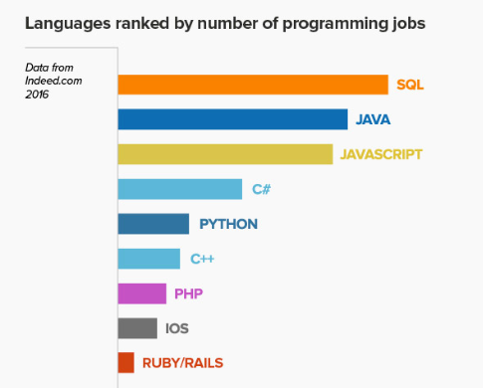
Background Information: There are hundreds and depending on how you count them, even thousands of computer programming languages. The great majority of these languages use + for their arithmetic operator of addition. The language COBOL and many assembly languages use ADD rather than +. The following table on currently popular programming languages may motivate a person to learn one language rather than another.
In two of our three contest languages,
Java and C++, the / operator for integer division
is the same. For Python 3.0 the // operator
is used for integer division.
In Java and C++: 17 / 5 will produce a quotient of 3.
In Python: 17 / 5 will give a floating point result of 3.4.
Python integer division, 17 // 5 gives 3 for an answer.

It is frequently useful for programmers to not only compute a quotient when doing integer division but to also compute the integer remainder. In all three of our contest languages the remainder operation is %. For example: 17 % 5 gives an answer of 2 which is the remainder.

Programming Problem:
Input: On separate lines, positive integers M and N with M, N < 1,000,000.
M is the dividend and N is the divisor.
Output: On one line, M, N, Q and R where Q is the (integer) quotient and R is the remainder
Each of the four values must be separated by one space.

Example : Input: 17

5

Output: 17 5 3 2

During the contest, Siena assistants will notify you when it is time to take a short break and get some pizza.

V1

