Siena College’s 32nd Annual High School Programming Contest

Sponsored by Transfinder

March 29, 2019

Gold Problem #6: The TRANSFINDER Problem

Background Information: There are mathematical puzzles that are sometimes called cryptarithmetics, alphametics, or word additions. This type of puzzle consists of a mathematical equation among unknown numbers, whose digits are represented by letters. To solve the puzzle, the value of each letter must be identified. One rule for these puzzles is that no digit is used by more than one letter. A second rule is that the final numbers will not have leading zeros. One of the most well-known puzzles was constructed by the famous math problem poser, Henry Dudeney, in 1924. It is: SEND + MORE = MONEY.
It may be helpful to lay out the problem as follows:
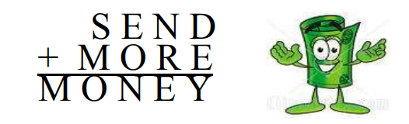
With some good logic, you can reach the only possible solution of
S = 9, E = 5, N = 6, D = 7, M = 1, O = 0, R= 8, and Y = 2 which can be written as follows:
9 5 6 7
+ 1 0 8 5
1 0 6 5 2
Rather than only relying on good logic, we want a program that can find solutions to word addition puzzles. Some puzzles may have more than one solution. If this is the case, we want the program to output the solution with the smallest possible numeric value of the first addend. If there is a tie with the first addend, then break the tie by outputting the solution with the smallest second addend. If there is no solution to the puzzle, this should be indicated.

Programming Problem:
Input: Three words in uppercase on one line, separated by a space. There will be
a maximum of ten different letters used in the three words.
Output: The solution of the word addition that minimizes the first, second, and third numbers (in that order). If there is no solution, the output is NO SOLUTION.
There will be no word with a numeric value greater than 2,000,000,000.

Example 1: Input: SEND MORE MONEY Example 2: Input: A B C

Output: 9567 1085 10652 Output: 1 2 3

Example 3: Input: ALPHABET LETTERS SCRABBLE Example 4: Input: CAT BIRD COOL

Output: 17531908 7088062 24619970 Output: 235 1769 2004

Example 5: Input: TRANS FINDR FIESTA Example 6: Input: AB CB BDB

Output: 93875 10723 104598 Output: NO SOLUTION

