SIENA COLLEGE
28th Annual High School Programming Contest

April 27, 2015

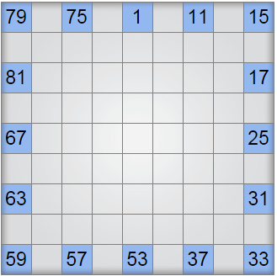
Problem #7: NUMBRIX
Background Information: A Numbrix logic puzzle is one where the solver must fill in the blank spaces of the puzzle with numbers so that each integer from 1 to 81 is entered in the grid exactly once, and a path exists such that you can move from space 1 to space 81 by moving through a chain of consecutive numbers

Rules for Numbrix:
- In a correct solution, for all squares x < 81, x is adjacent to x+1 (either horizontally or vertically).
- The grid will always be a 9x9 square, holding 81 numbers.
- No number in a solution is repeated.
- The input for this problem will be 9 lines of integers, each line representing the rows 1 through 9. Zeroes in the input indicate a blank space in the grid. In the input, one space separates numbers in the row. No blank lines appear in the input.
- The non-zero input numbers must remain in their exact starting locations in the output.
- To make it easier to evaluate solutions, single-digit boxes should have a leading zero in the output.

Programming Problem:
Input: 9 lines, each containing 9 integers as described above separated by single spaces.
Output: 9 lines, each containing 9 integers separated by single spaces, representing the solution to
the puzzle according to the rules above.

Example:

Input: Output:
79 78 75 74 01 10 11 14 15
80 77 76 73 02 09 12 13 16
81 70 71 72 03 08 19 18 17
68 69 46 45 04 07 20 23 24
67 66 47 44 05 06 21 22 25
64 65 48 43 42 41 28 27 26
63 62 49 50 51 40 29 30 31
60 61 56 55 52 39 36 35 32
59 58 57 54 53 38 37 34 33
79 0 75 0 1 0 11 0 15
0 0 0 0 0 0 0 0 0
81 0 0 0 0 0 0 0 17
0 0 0 0 0 0 0 0 0
67 0 0 0 0 0 0 0 25
0 0 0 0 0 0 0 0 0
63 0 0 0 0 0 0 0 31
0 0 0 0 0 0 0 0 0
59 0 57 0 53 0 37 0 33

